Description: E:\2010 Directory\Logo review\Finals as of August 2010\LJBC College Logo 19 grey 14 Sept.eps **Lake Joondalup Baptist College**

**Sound Waves Test**

**Name: SOLUTION Total Marks _______**

**------------------------------------------------------------------------------------------------**

**Section 1 (Multiple choice questions) (10 marks)**

Circle the one best alternative unless the question specifically states that there may be one or more correct answers.

---------------------------------------------------------------------------------------------------------------------------

1. Sound is
   * 1. a wave which travels through any material or a vacuum.
     2. a wave which travels only through air.
     3. a wave which travels through many materials but not a vacuum
     4. particles which travel through most things.
2. We set up a loud speaker at the front of the room at ear level. the sound waves that pass thru' the room towards you will cause the air molecules in their path to
   * 1. vibrate vertically up and down.
     2. vibrate horizontally back and forward.
     3. vibrate both vertically and horizontally.
     4. move toward you in waves.
3. The ‘pitch’ of a musical note is normally given in terms of its
   * 1. amplitude.
     2. frequency.
     3. wavelength.
     4. speed.
4. The normal frequency range of hearing in a young person (who hasn't been to too many pop concerts) is about

A 10 Hz to 10 kHz

B 20 Hz to 20 kHz

C 30 Hz to 30 kHz

D 100 Hz to 10,000 Hz

1. I am listening to some music through an open door at the concert hall but I can't see any of the orchestra. I will hear
   * 1. the violins better than the cellos.
     2. the cellos better than the violins.
     3. there will be no difference in the two.
     4. we would have to go to a concert to find out.
2. The sound of a flute is different to, say, a clarinet playing the same note because
   * 1. they produce different fundamental frequencies.
     2. they produce sound of different amplitudes.
     3. one produces transverse waves and the other longitudinal waves.
     4. they produce a different range of overtones.
3. Virtually all musical instruments depend on resonance. Which of these best describes what is meant by resonance?
   * 1. The superposition principle which says that the overall displacement of a wave is the vector addition of the individual displacements of separate waves.
     2. When waves coming from two or more sources reach the same region they will combine in such a way as to cause constructive or destructive interference.
     3. Waves trapped in a confined space will always interfere with each other to produce a bigger wave.
     4. Waves trapped in a confined space will sometimes interfere with each other to produce standing waves.
4. A flute can be regarded as an air tube open at both ends. This means that when it is played, the pressure variation standing waves will be such that at the ends there will be
   * 1. nodes at both ends.
     2. antinodes at both ends.
     3. a node at one end and an antinode at the other end.
     4. a node or an antinode depending on the note being played.
5. A clarinet is effectively an air tube closed at one end and open at the other. This means that the wavelength of the fundamental note produced will be
   * 1. equal to the length of the clarinet.
     2. half the length of the clarinet.
     3. twice the length of the clarinet.
     4. four times the length of the clarinet.
6. A flute is tuned to the rest of the orchestra by adjusting its length slightly. Compared to the length on a cool day, on a hot day (when the speed of sound is higher) to tune the flute to the correct frequency the length will need to be

A slightly greater

B slightly less

C a lot less

D unchanged

**End of Multiple Choice Section**

**Section 2 : Written Answers (40 marks)**

Show your working out neatly, clearly and logically in order that part marks may be awarded.

**------------------------------------------------------------------------------------------------------------------------------------**

**11 (4 marks)**

The two diagrams below show wavefronts incident on gaps of different width. On each diagram draw five (5) wavefronts to show how the waves behave after they have passed through the gap.

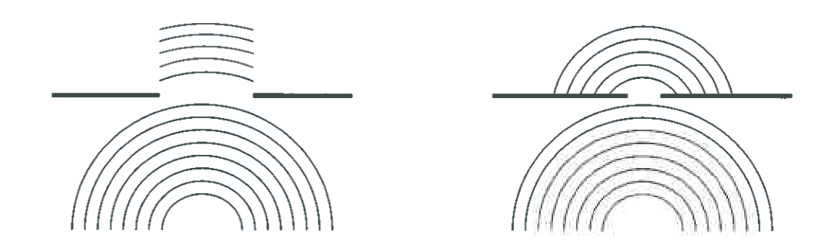

**12. (15 marks)**

An organ pipe X, with both ends open, sounds its fundamental frequency of 300 Hz. Dry air at 250 C is in the pipe.

a) Which of the following diagrams below best represents the particle displacement in the pipe?

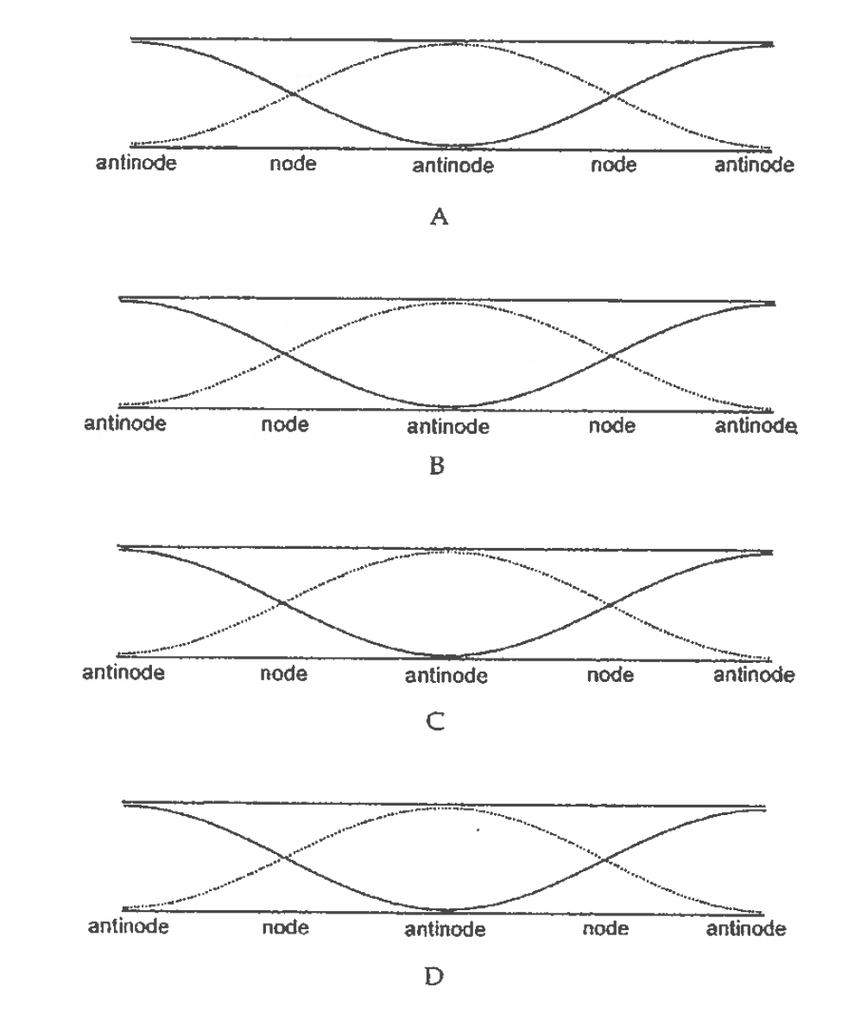

ANSWER:  **DIAGRAM B**

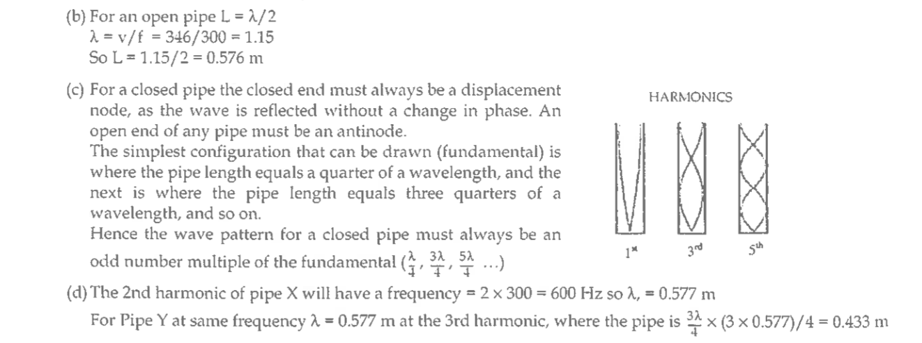

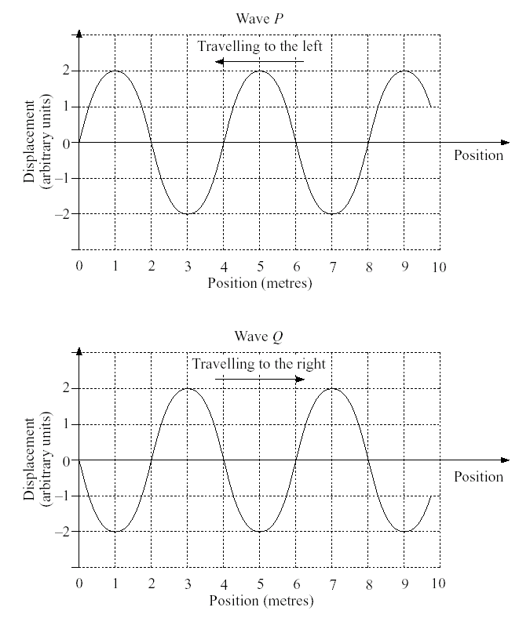**13. (4 marks)**

Two **water waves**, P and *Q*, shown in the diagram below, are travelling with equal amplitudes. Both waves are shown to the same scale. Each has a wavelength of 4·0 m, and a frequency of 5·0 Hz.

a) What is the period of each of the waves?

**Period = 1/freq = 1/5 = 0.2 sec**

---------------------------------------------------------------------------------------------------------------------

b) What is the velocity of the waves?

**Velocity = freq x wavelength = 5.0 x 4 = 20 m s-1**

----------------------------------------------------------------------------------------------------------------------

c) How much out of phase are the two waves ***P*** and ***Q***

**1800**

----------------------------------------------------------------------------------------------------------------

1. In which direction is the particle at displacement 0 and position 2 moving at the instant in time shown in the wave ***P*** graph.

Position 0 particle is moving UP

Position 2 particle is moving DOWN

**14. (4 marks)**

The diagram below shows a section lengthwise through a bird whistle capable of making sounds over a large range of frequencies. The frequency can be changed by moving the plunger inside the whistle. The longest length of the whistle is 8.7 cm.

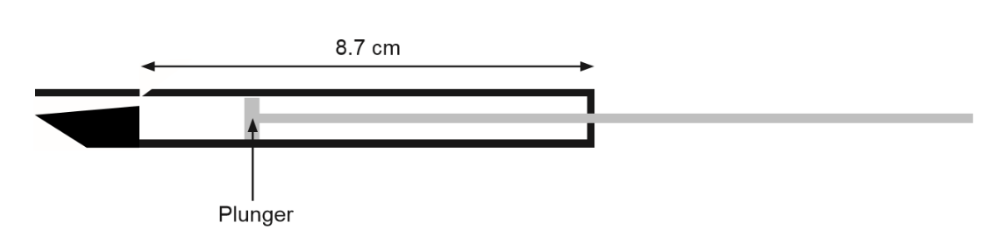

You should assume that air at 25°C is in the whistle.

a) Determine the distance moved by the plunger when changing the fundamental note from 18 kHz to 21 kHz, and

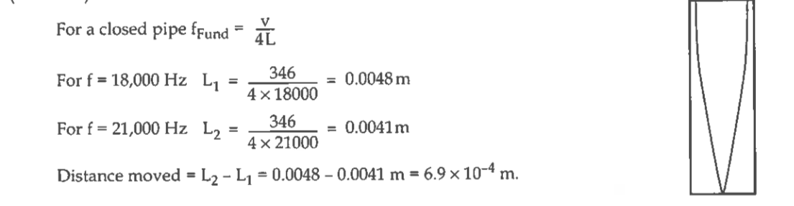

b) Draw a diagram of the fundamental wave in the whistle.

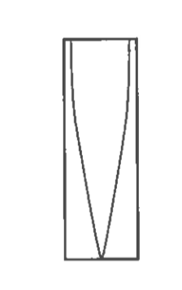

**15 (5 marks)**

Two identical plastic tubes, *1* and *2* each have one end immersed in water. By changing how deeply the tubes are immersed in the water, the lengths of the air filled parts of the tubes can be varied. The diagram below shows the set up. A tuning fork generating 256 Hz sound is held above *tube 1* and, after small adjustments to the tube’s immersion depth, it is found to resonate with the sound from the tuning fork. *Tube 1* is clamped in position at that depth. The *tube 2* is then held at the same depth with the tuning fork sounding above it. It, of course, resonates as did the *tube 1*. Its immersion depth is decreased slowly. At first, it stops resonating but as its depth decreases it again resonates with the sound from the tuning fork. The difference in the length of the air filled parts of *tubes 1* and *2*, *Δl*, is measured.

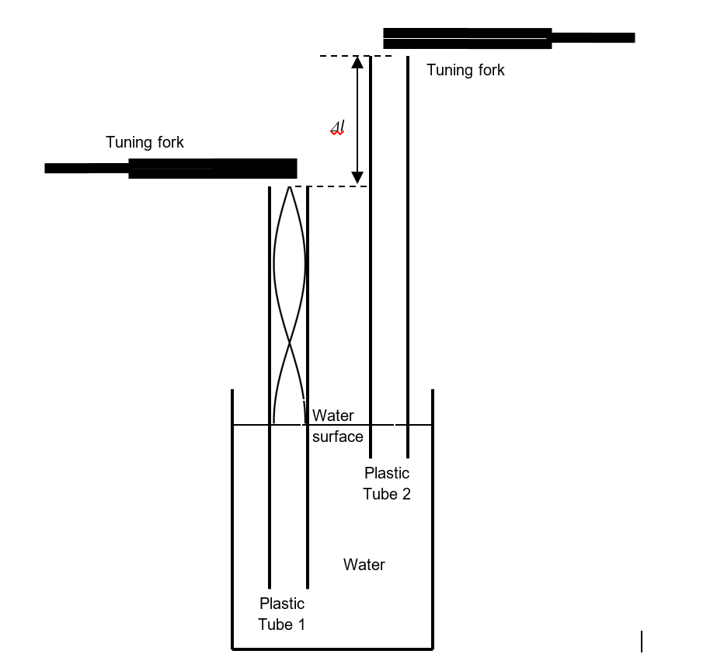

a) The lines in the *tube 1* show are a sketch plot of the minimum and maximum of the pressure variations in the deeper tube. In a similar manner, show the pressure variations in the second tube by sketching the minimum and maximum of the pressure variations in *tube 2*. (2 marks)

b) The value of *Δl* is 66 cm. Use this figure to calculate the velocity of sound for the air. (3 marks)

*Δl* = λ = 66 cm = 0.66 m

2

Hence λ = 2 x 0.66 = 1.32 m

Velocity = λ x 256 1.32 x 256

= 338 m s-1

**16 (5 marks)**

A park has a circular fence around it. The top rail of the fence is a metal pipe. Mrs Vickers sets a group of students the task of finding ***the radius of the*** *fence* by applying their knowledge of sound. Dino hits the pipe with a hammer giving a sound of 350 Hz. Dom, standing directly opposite on the other side of the park, detects two sounds, 0.30 s apart. If the speed of sound is 330 m s-1 in air and 1310 m s-1 in this metal pipe, what is the radius of the fence? (hint: circumference of a circle =2x π x radius).

Time for sound to travel through air = dia of oval = 2 x r sec

velocity 330

Time for sound through steel pipe = circumf of semicircle = π x r sec

velocity 1310

Now 2x r - π x r = 0.30

330 1310



2 x r x 1310 - 330(π x r) = 0.30

330 x 1310

(2620 – 11036.9) r = 0,30x330x1310

r = 0.30x330x1310

(2620 – 11036.9)

Solving to give radius r = 81.9

Hence radius of oval is 82 m

**17. (3 marks)**

A loudspeaker produces sound waves in air of wavelength 0.34 m and speed 340 m s-1. How many cycles of vibrations does the loudspeaker cone make in 50 m s?

**Frequency = 340 / 0.34 = 1000 Hz (cycles of vibrations/sec)**

**In I sec there are 1000 vibrations**

**50 x 10-3 sec there are x vibrations**

**X = 1000 cycles of vibrations/sec x 50 x 10-3 sec**

**= 50 cycles of vibrations**

**END OF TEST**

**End of test**